# User Dashboard App

## Folder Structure :

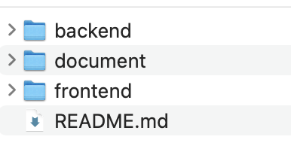

Backend : folder include mock Rest API by using Express.js

Frontend : Folder structure

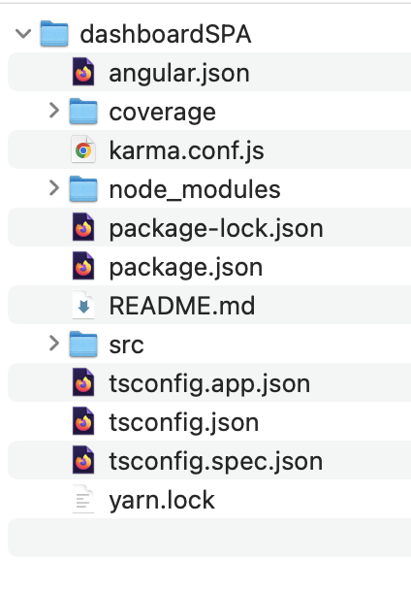

**Code coverage** : DashboardSPA folder include test coverage report

To run test report : *ng test --code-coverage*

**Application folder : src**

Source files for the root-level application project.

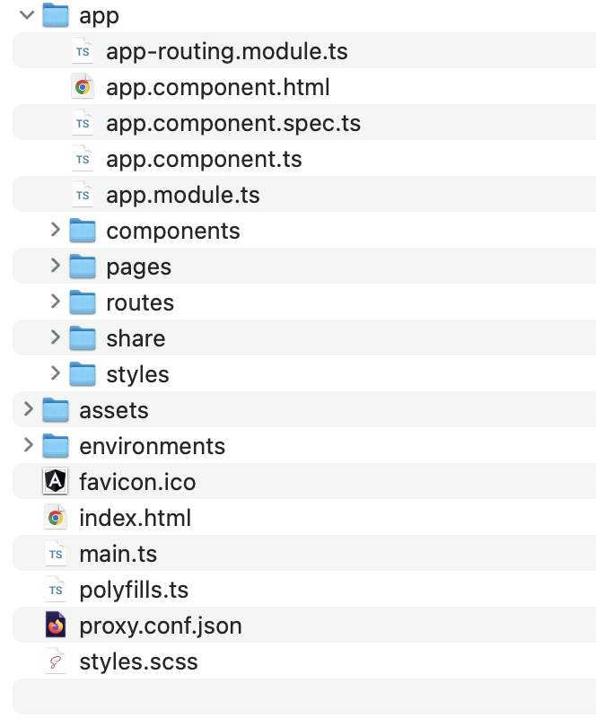

**Environments folder**: To use the environment configurations you have defined Using environment-specific variables

**Assets folder**: Contains **image, icons , api-config ,languages** and other asset files to be copied as-is when you build your application.

Styles.scss: Lists CSS files that supply styles for a project. The extension reflects the style preprocessor you have configured for the project.

Angular.json: CLI configuration defaults for all projects in the workspace, including configuration options for build, serve, and test tools that the CLI uses, such as [Karma](https://karma-runner.github.io/), and [Protractor](https://www.protractortest.org/). For details, see [Angular Workspace Configuration](https://angular.io/guide/workspace-config).

Package.json Configures [npm package dependencies](https://angular.io/guide/npm-packages) that are available to all projects in the workspace. See [npm documentation](https://docs.npmjs.com/files/package.json) for the specific format and contents of this file.

Proxy.conf.json: Proxying to a backend server

### Screen capture of Application

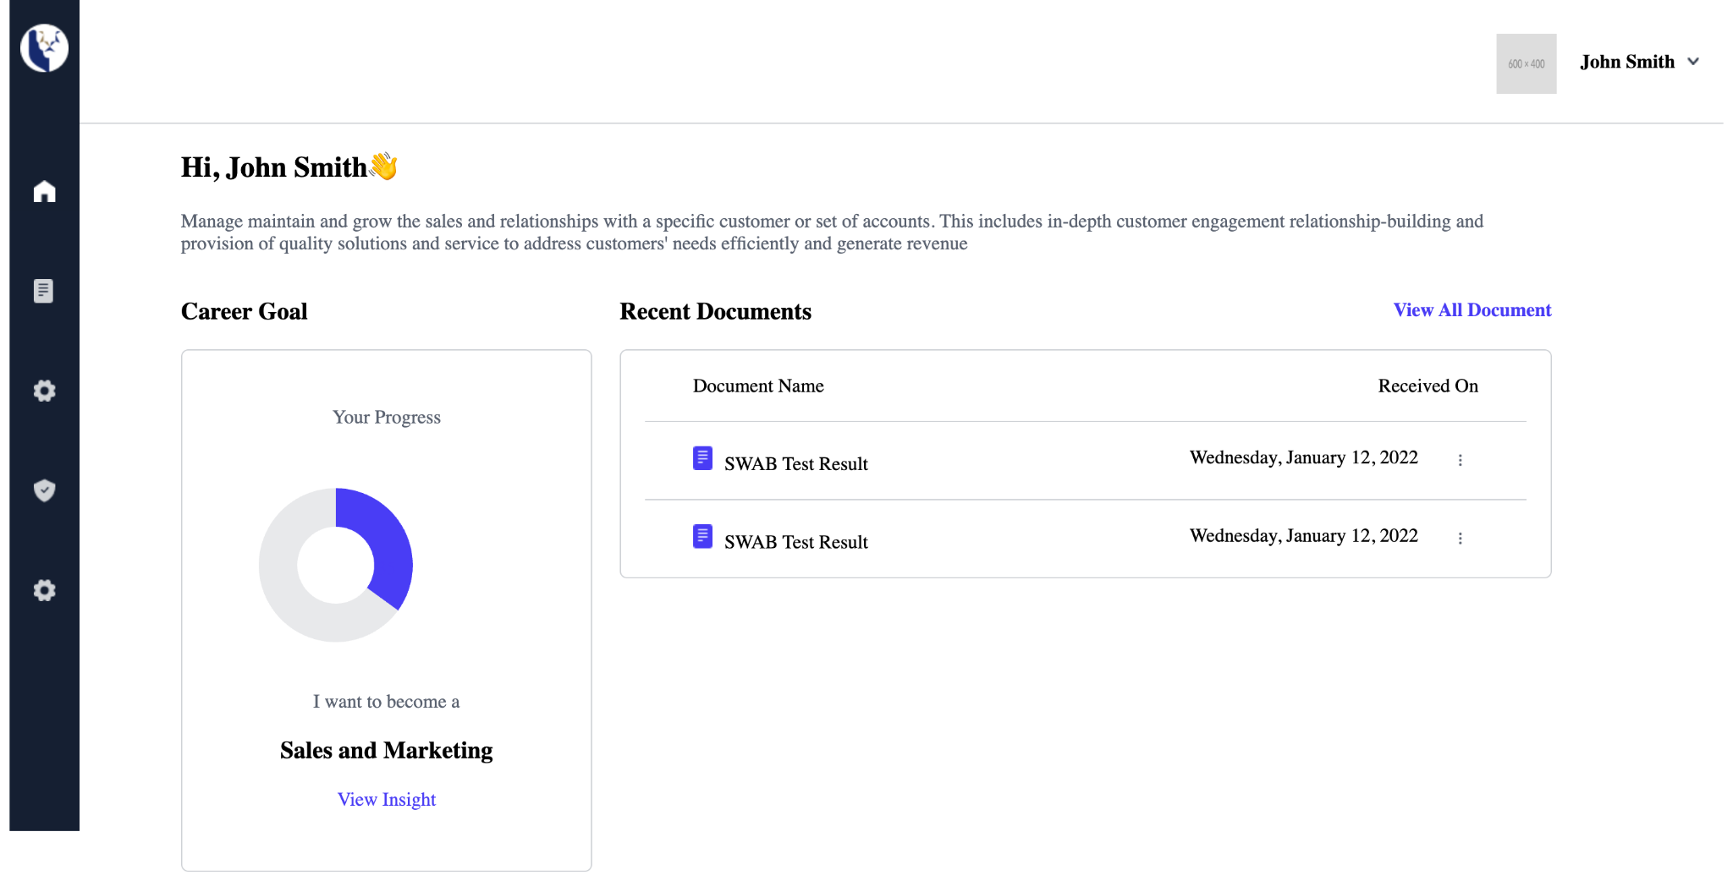

Desktop Manage User View

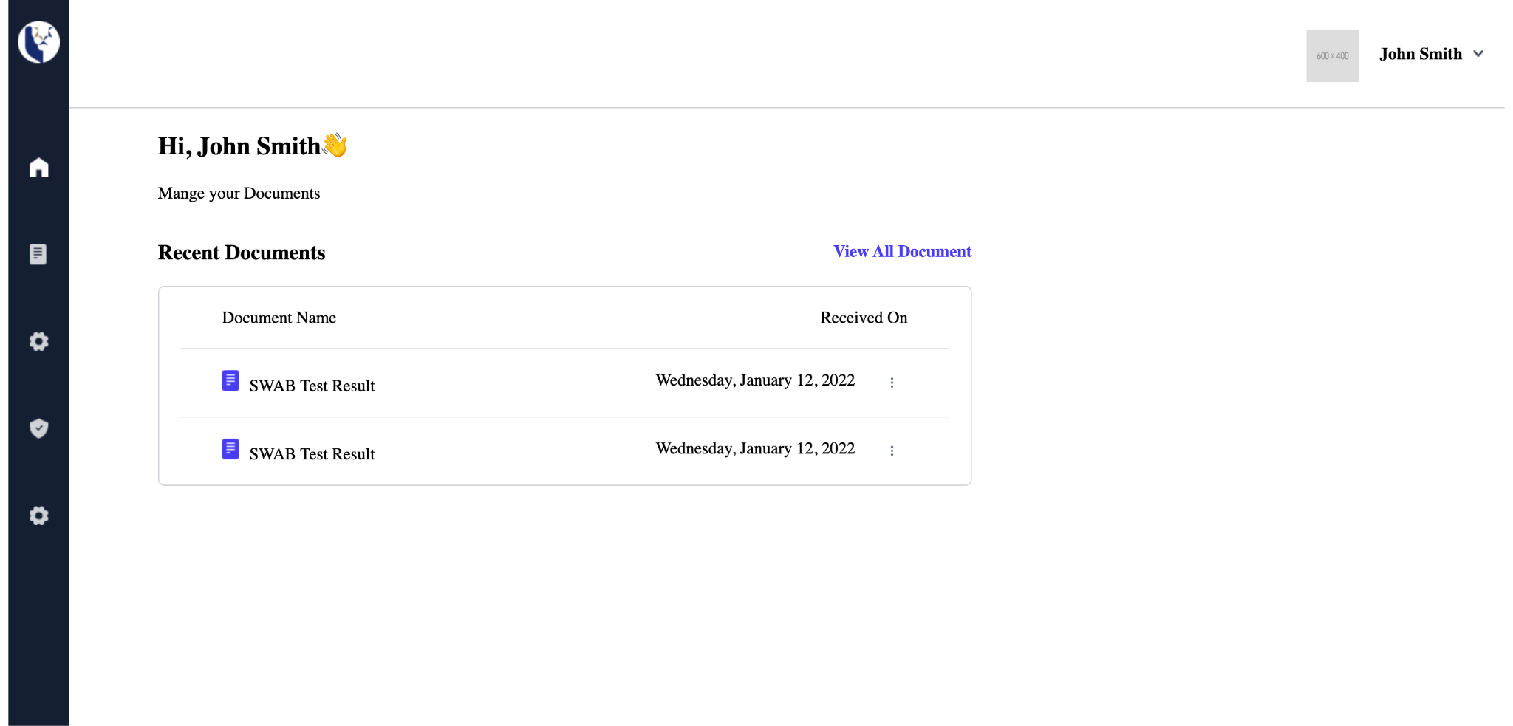

Desktop personal User View

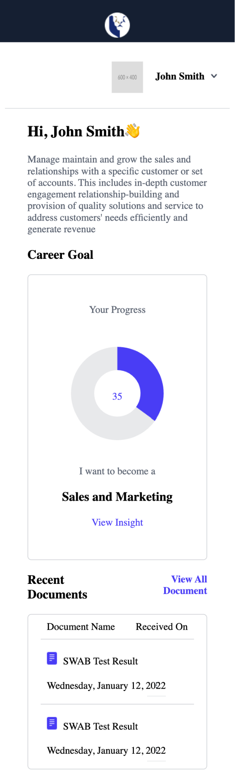

Mobile User View

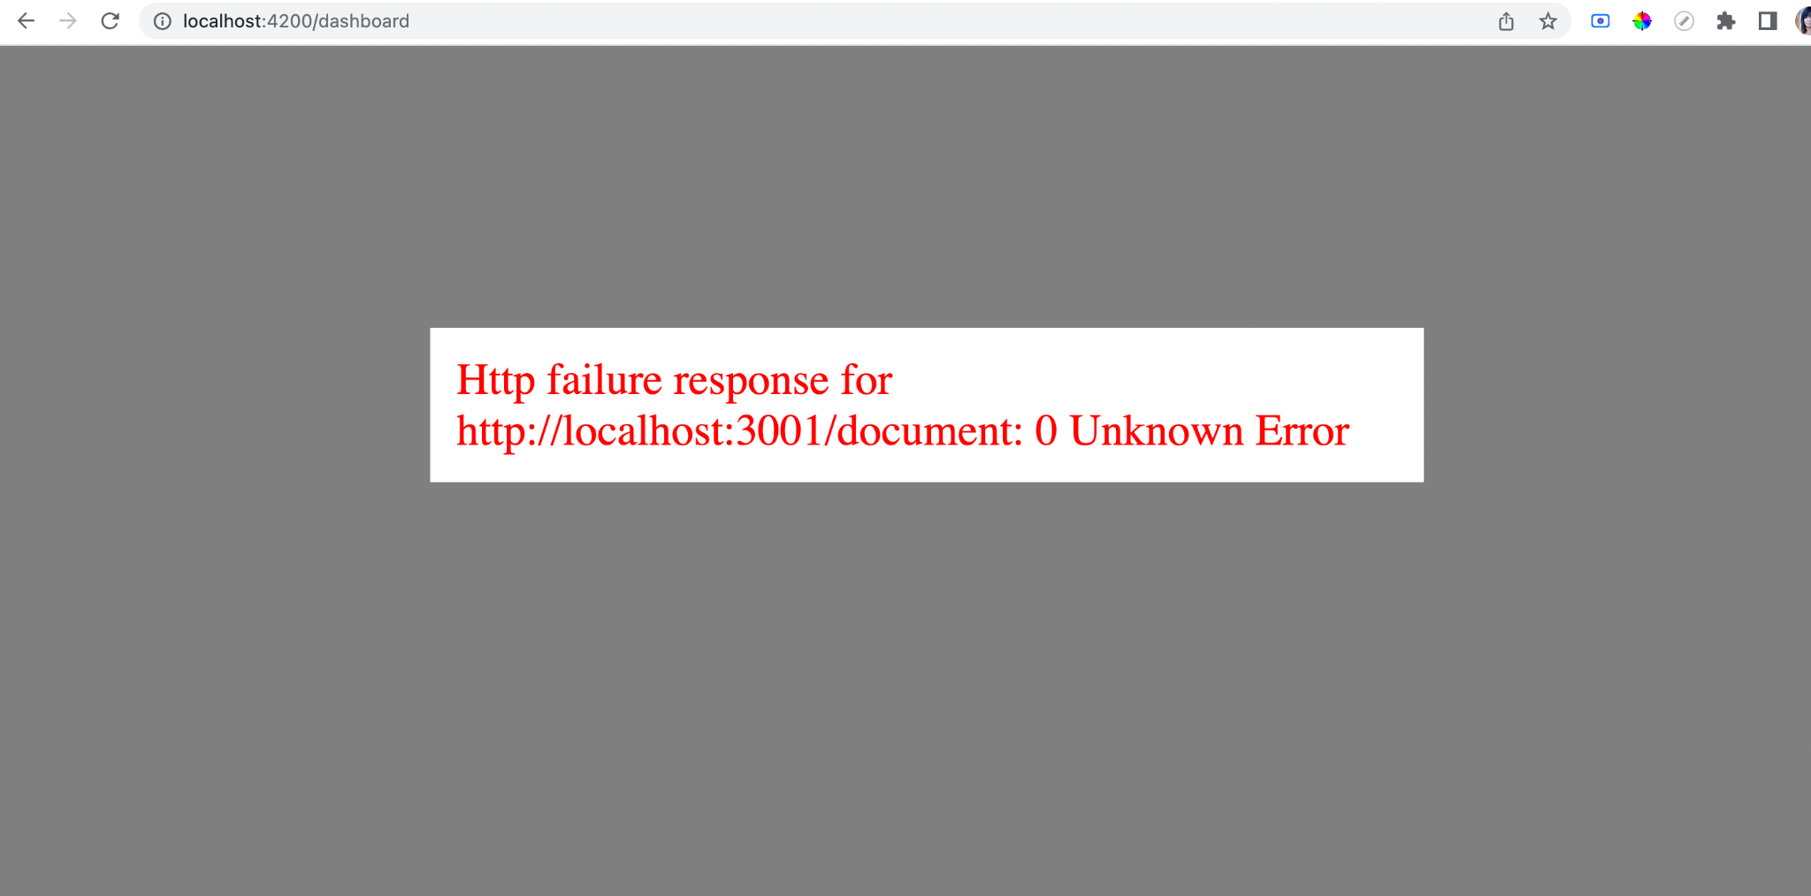

Network Error View: In order to test it , change invalid backend url port in environment.ts

export const environment = {

production: false,

API_ROOT: 'api/',

MOCK: 'http://localhost:3000/'

};

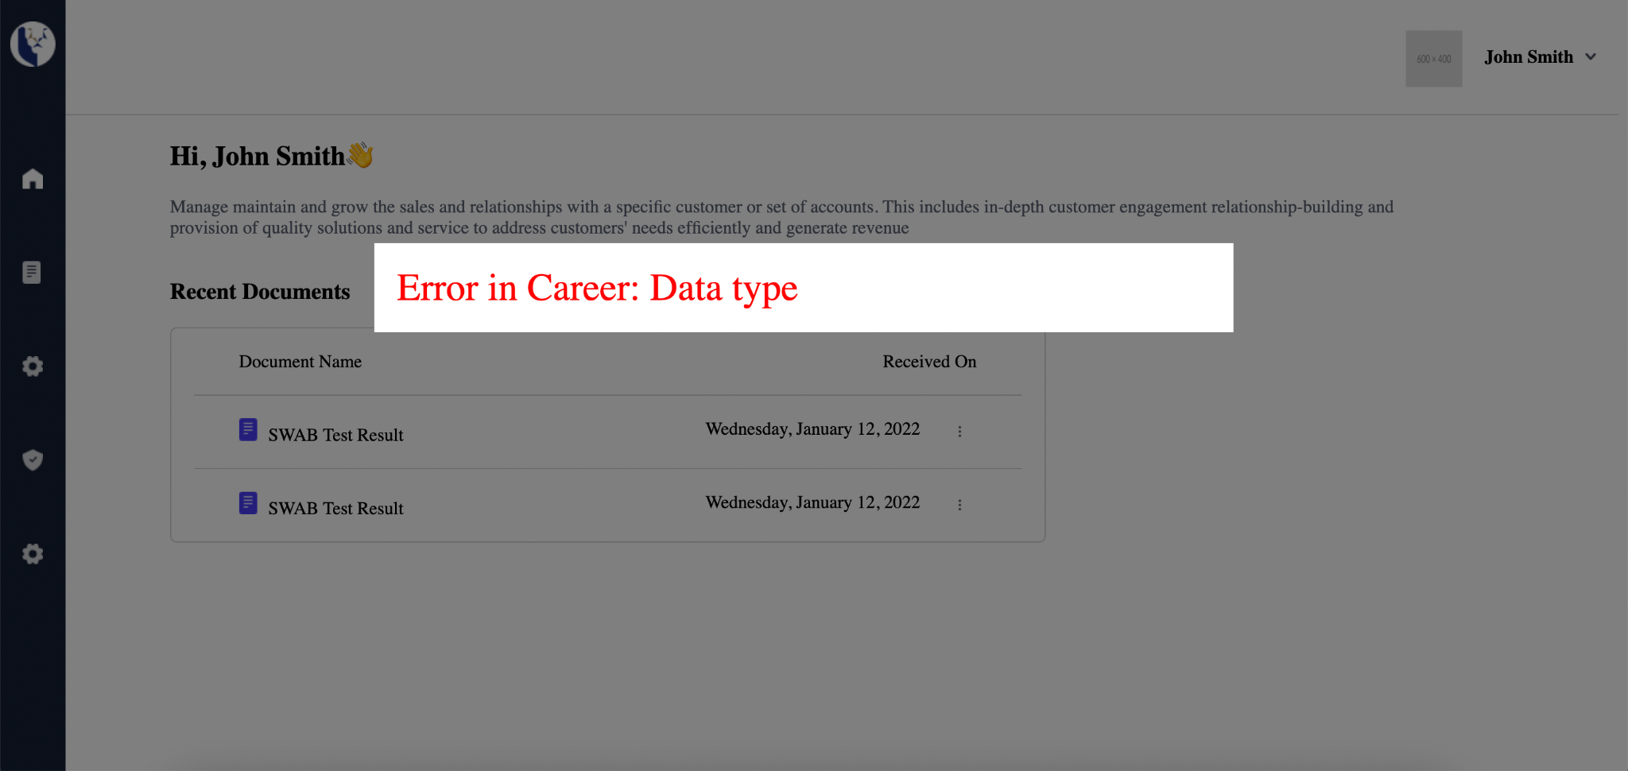

Datatype: Validation Error View

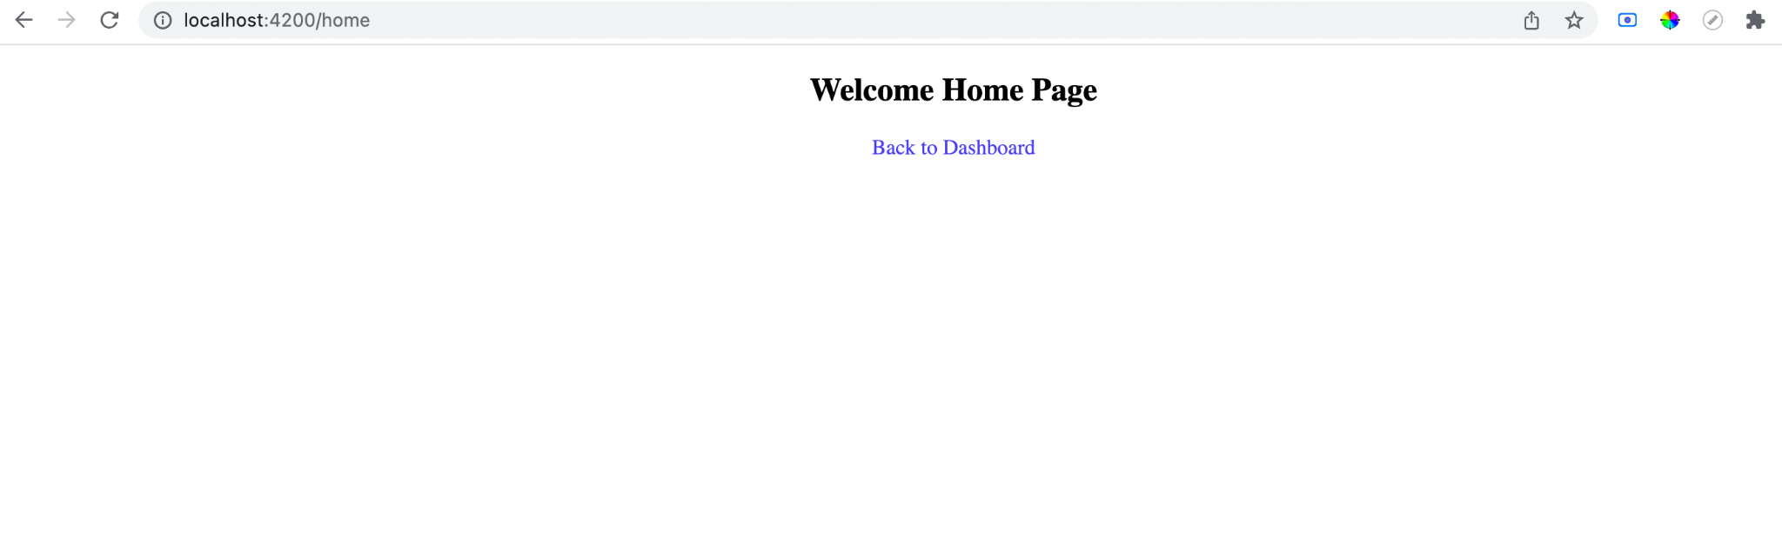

Home Page: after logout view